Objective
Analysis how Bitcoin market sentiment (Fear/Greed Index) trader behaviour and performance.
Part 1) Key Metrics Analyse :
- Daily PnL per trader

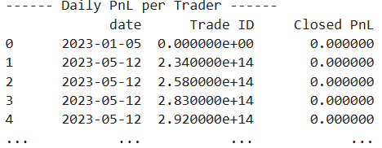
- Win rate and Average trade size
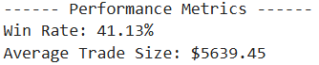
- Leverage distribution
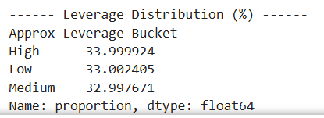
- Trades per day
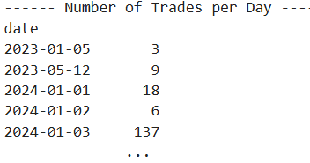
- Long/short ratio
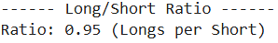
Part 2) Analysis:
- Table shows analysis performed between feer and greeds days based on PnL, win rate, drawdown proxy

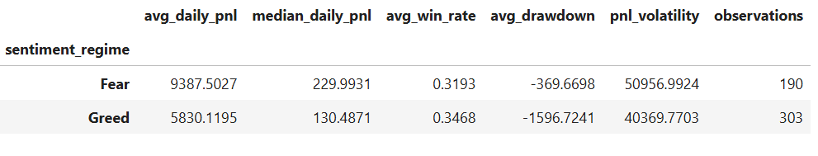
- Average Daily PnL (Fear vs Greed)

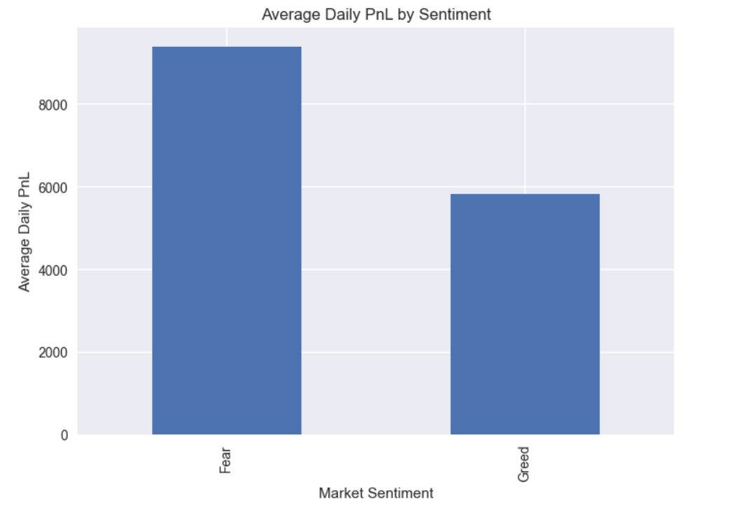
- Win Rate Comparison

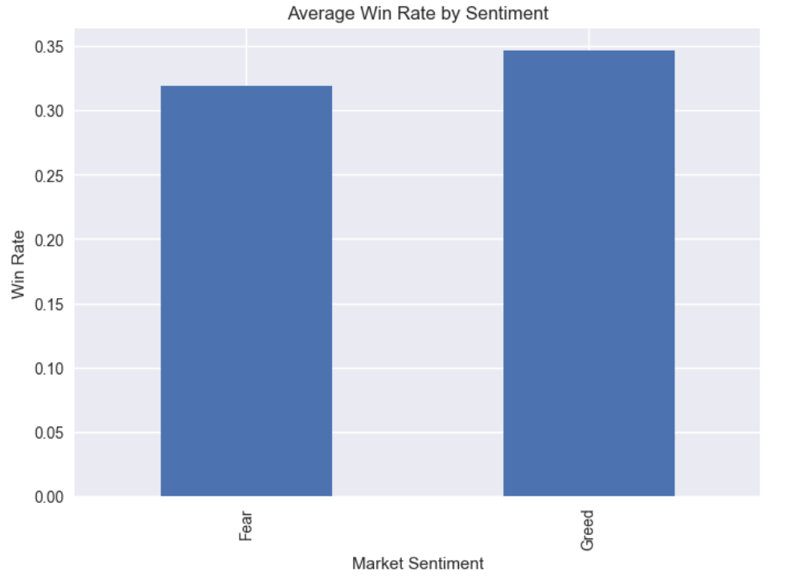

Win rate consistently improves during Greed days.
- Drawdown Proxy
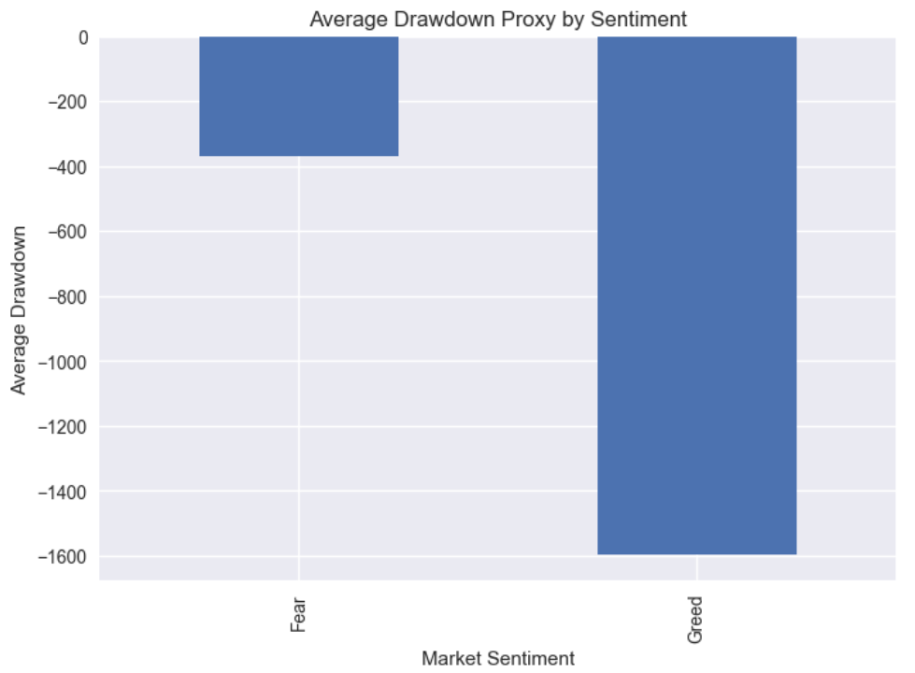
Greed days show larger negative drawdowns.

- PnL Distribution
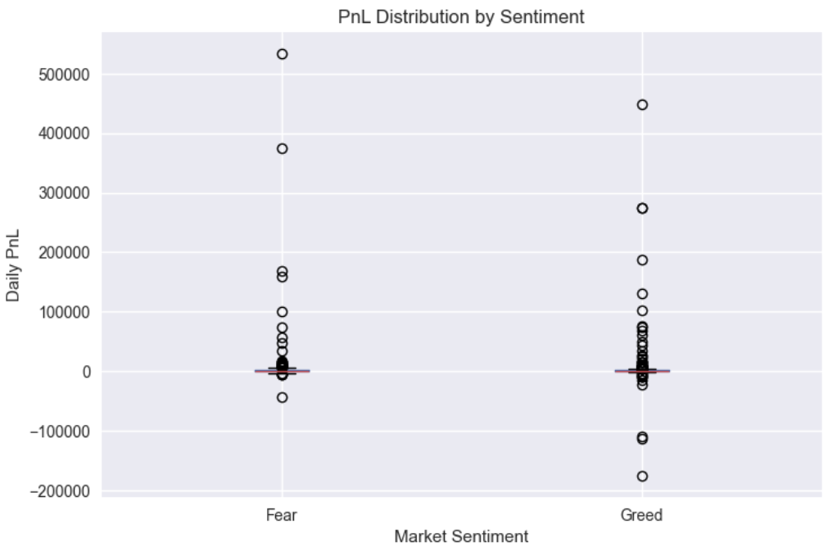
Greed → wider spread, fatter downside tail
Fear → tighter, upward-shifted distribution

- Traders change behaviour based on sentiment (trade frequency, leverage, long/short bias, position sizes)
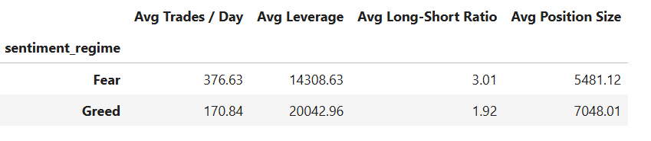
- Segments
  - High leverage vs Low leverage traders
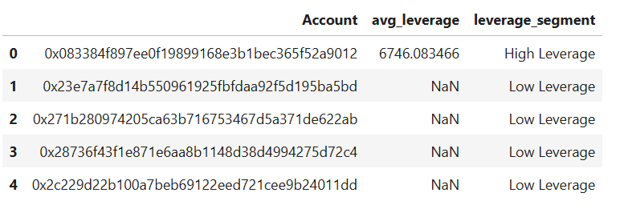
  - Frequent vs Infrequent traders
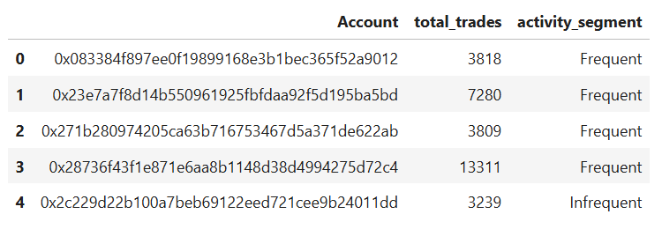
  - Consistent winners vs Inconsistent traders
